|  |  |
| --- | --- |
| PH 201-8  Quiz 3  Constant Acceleration | Name: ______KEY____________________________  (please print and also put your name on the back) |

1. Fill in the 5 blanks on the chart below (5pts)
2. Given the following portion of an excel spreadsheet, what should go in cell D1 so that it displays the average of the other 3 cells? (1pts)

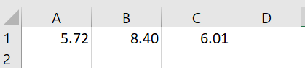 “=average(a1:c1)”

1. A track like the ones used in last week’s lab is set up and its height is measured at 2 points yielding 6.0cm and 8.4cm. The distance between them (measured along the track and not the top of the lab table) is 42cm. Assuming that gravity exerts an acceleration of 9.807, find the component of the gravitational acceleration that acts on a cart released down the track. (4 pts)